STUDENT AND PARENT
Teaching and Learning Bulletin
No. 6
Welcome to the sixth and final Teaching and Learning bulletin for students and parents in this academic year.
The aim is to inform you once a term of the techniques that the teachers at PHSG are using in their lessons and the revision/memory strategies that we are encouraging the students to use in order to learn and recall information and methods that we teach them every day.
In this issue I will share with you:
- Knowledge Banks

For more information about PHSG and Thinking click here : Plymouth High School for Girls - Thinking Schools Academy Trust (phsg.org)

Knowledge Banks
For students to succeed in a particular area, they must have a foundation of factual knowledge, understand those facts in the context of a conceptual framework and organise knowledge in order to facilitate retrieval and application (Bransford et al, 2000)
A knowledge bank is the information in the curriculum summarised into an accessible framework - it does not replace the curriculum but secures access to it.
Retrieval practice is bringing knowledge to mind from memory. Using knowledge banks to make clear to our students what the most important information in our subject is gives us a real opportunity to repeatedly and actively retrieve this information. The outcome will then be automatised knowledge and will therefore give more capacity in working memory to focus on other elements of the task.
Using a Knowledge Organiser Template allows students to make links, which allows information to move into their long-term memory. For teachers, the knowledge organiser serves as a powerful knowledge tool that provides supports while teaching a lesson.
What are knowledge organisers?
Knowledge organisers contain essential, fundamental knowledge that students MUST know in order to be successful in Year 7 and subsequent years. They will help students to recap, revisit and revise what they have learnt in lessons, enabling them to move the knowledge from their short-term memory to their long-term memory. Knowledge organisers are designed to help students learn a wide range of knowledge which in turn will mean that they are more prepared for lessons as well as assessment that they will sit in the future.
Why use Knowledge Banks?
Working memory is slow and what we want is for students to be able to recall key information and methods quickly so that in an examination they can focus on how to answer the question to the best of their abilities without having to recall key facts, dates, people, quotes, formulae etc
Learning often contains misconceptions—inaccurate or incomplete information—that are highly resistant to change because existing knowledge networks must be restructured to accommodate counterintuitive information in a process known as conceptual change.
How can I access the knowledge organisers?
Each subject area has created a knowledge organiser for the topics that students will cover over the year. These will be given out in paper format but will also be available on TEAMS. It is really important that students keep all of their knowledge organisers somewhere safe, because the knowledge required in Year 7 will also be needed in Years 8-11.
How will the knowledge organisers be used?
Students will use their knowledge organisers in lessons, but they will mainly use them to assist with their homework tasks and preparation for assessments. Most of the time, teachers could give specific tasks focused around the knowledge organiser for class and homework. They will be very useful in developing student’s confidence at home with topics that have been covered in class.
Examples of Knowledge Banks
Geography
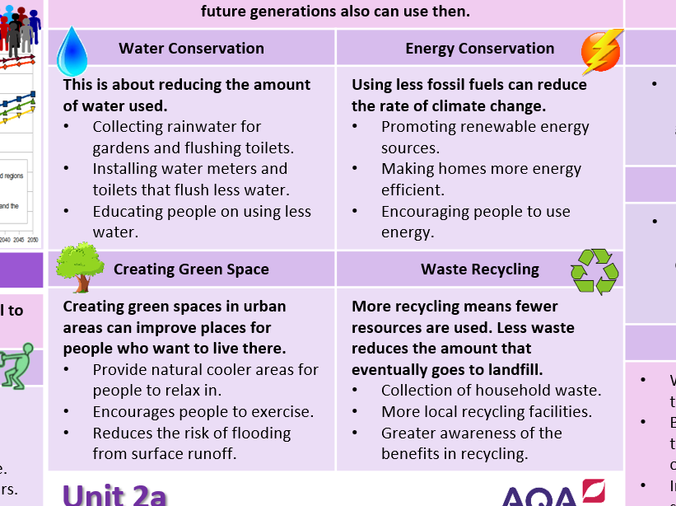
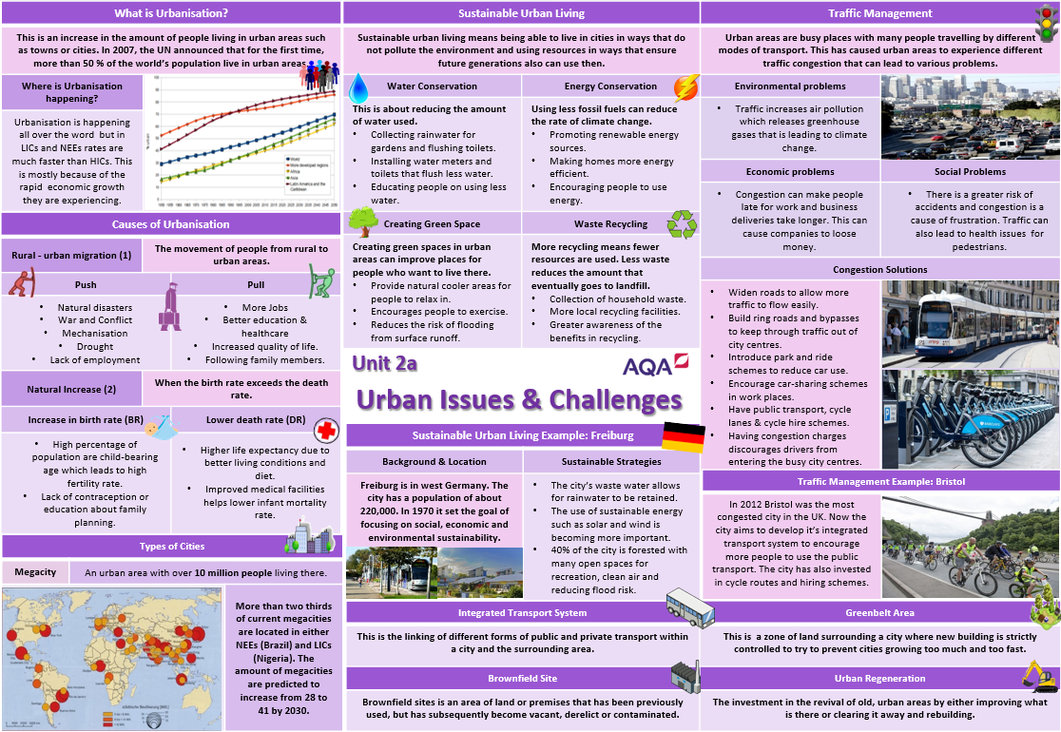

Art
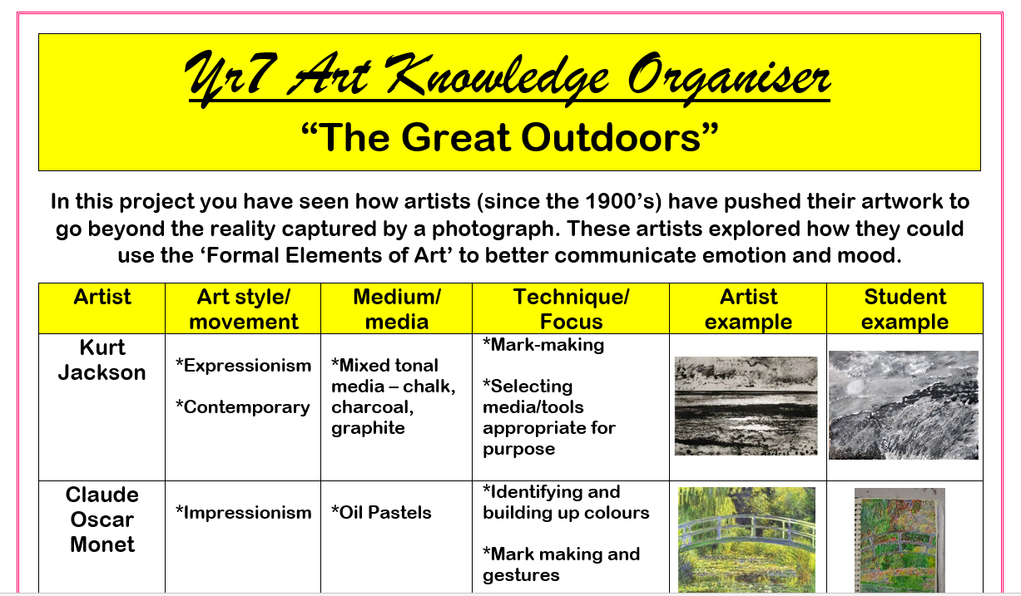
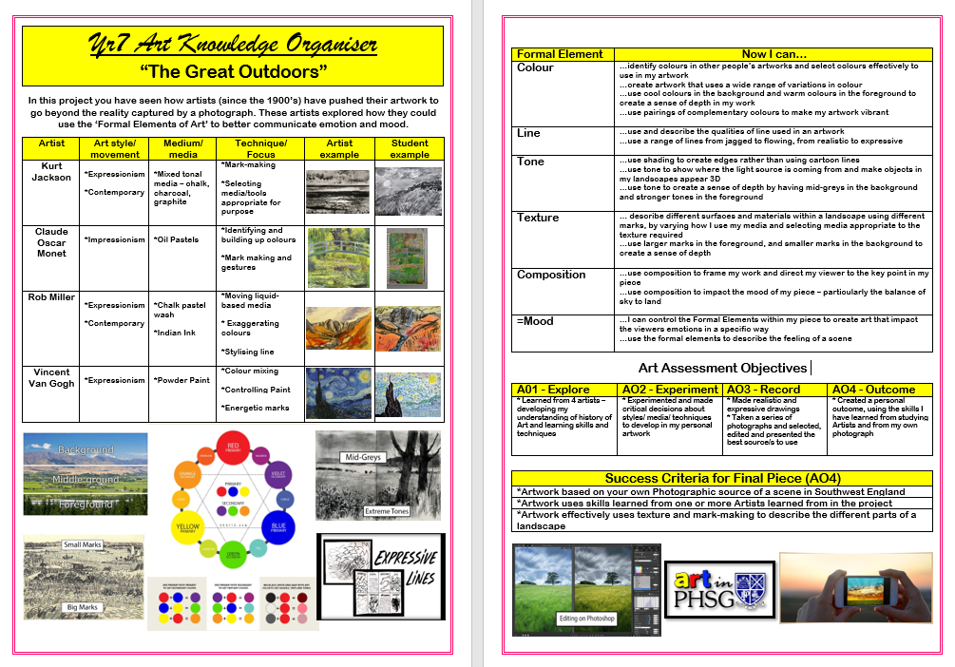

English
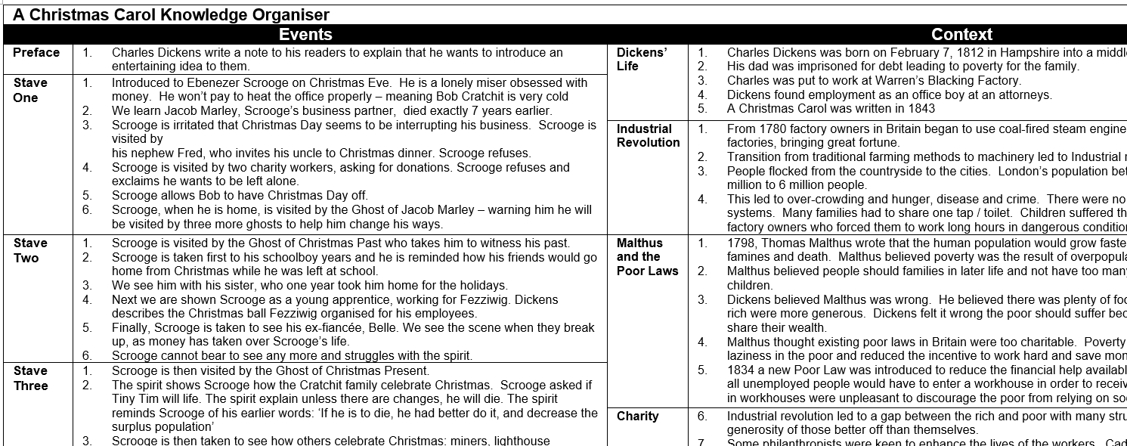

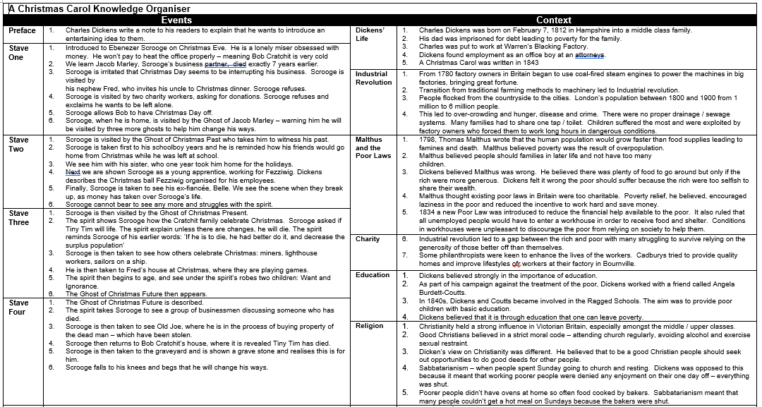
Homework tasks will be set where students are asked to learn and self-test using the knowledge banks.
- Can they rewrite them?
- Can they cover up sections of the knowledge banks and recall the content by self-testing?
- Can they answer questions set on Carousel based on the knowledge bank content?

How to use a knowledge bank – a practical guide for students
 | Look, Cover, Write and Check | Definitions to key words | Flash cards | Self- Quizzing | Thinking maps | Paired Retrieval
STEP1 | Look at and study a specific area of the knowledge organiser | Write down the key words and definitions | Use the knowledge organiser to condense and write down key facts and information onto flash cards | Use your knowledge organiser to create mini quizzes. Write down questions using your knowledge organiser | Create a thinking map with all the information you can remember from your organiser.  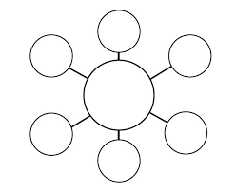 | Ask a friend or family member to quiz you
STEP 2 | Cover or flip the knowledge organiser over and write down everything that you can remember | Try not to use your knowledge organiser to help you | Add pictures to support you -dual coding. Then self-quiz using your flash cards.  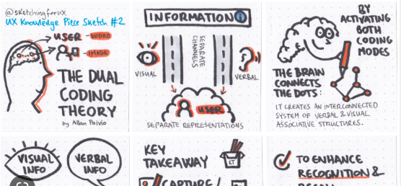 | Answer the questions and remember to use full sentences | Check your knowledge organiser to see if there were any mistakes with the information you have made | They can test you by asking you questions on different sections of the knowledge organiser
STEP 3 | Check what you have written down, Correct any mistakes in a different colour. | Use a different colour to check your work. | Use a friend or family member to help quiz you. | Use a friend or family member to help quiz you. | Try to make connections that links information together. | Write your answers down

