STUDENT AND PARENT
Teaching and Learning Bulletin
No. 5
Welcome to the fifth Teaching and Learning bulletin for students and parents.
The aim is to inform you once a term of the techniques that the teachers at PHSG are using in their lessons and the revision/memory strategies that we are encouraging the students to use in order to learn and recall information and methods that we teach them every day.
In this issue I will share with you:
- What is feedback?
- Acting on feedback

For more information about PHSG and Thinking click here : Plymouth High School for Girls - Thinking Schools Academy Trust (phsg.org)

Feedback
Feedback is part of the complex fabric of high-quality teaching that teachers work hard to implement successfully in their classrooms.
Feedback is information given to the learner about the learner's performance relative to learning goals or outcomes.
It should aim to and be capable of, producing improvement in students' learning.
Feedback redirects or refocuses the learner's actions to achieve a goal, by aligning effort and activity with an outcome.
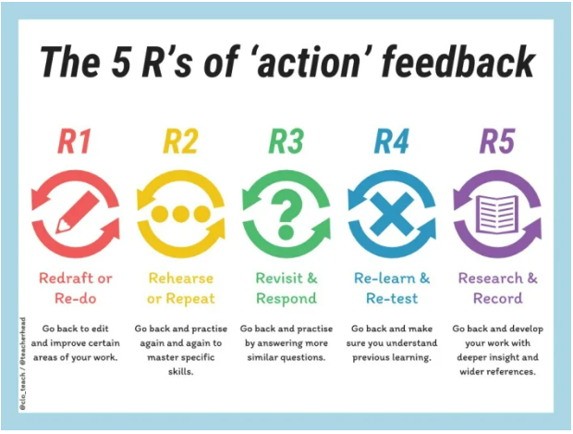

Being specific.
General feedback like “great job” or “almost there” is easy to give, but not always easy for students to understand. Staff will offer feedback detailing exactly what students are doing well (WWW), or what they need to improve upon (EBI.

Explain feedback wherever possible.
Teachers will take feedback even further by offering detailed explanations of how to improve a piece of work. For example, “Use more descriptive words” may be helpful feedback for students’ writing, but it can be made even more useful with a reason why: “Adding more descriptions here will help paint a picture in your readers’ mind.”

Feedback isn’t just for finished work.
Teachers will provide feedback at the end of a completed task—after a test, an essay, a project, and so on, but the most effective feedback is actually given during the creation process, because it gives students the chance to shift and pivot their work in the moment. Teachers will endeavour to try to offer feedback to students throughout every step of the learning process, so they can put the suggestions into practice right away.

Give feedback one-on-one.
The best feedback is given on a personalized, individual level, rather than as addressed to an entire group. Studies show that when feedback is given to a whole group, most of the group members’ natural assumption is that the feedback applies to everyone else—so they aren’t likely to take it into consideration for themselves. By offering personal, one-on-one feedback, teachers show students that we are aware of what they’re doing on an individual level, and that we are there to support them.

Allow time for questions and discussion.
Sometimes, the feedback offered to students may not resonate completely with them the first time around. By offering students a chance to ask questions about feedback, we can give them an opportunity to understand it with greater depth. Discussing their feedback—either with the teacher or a group of peers—can also be a great way to help students consider their feedback beyond the surface level.

Student autonomy facilitates self-reflection.
Having students reflect on their own work is a common practice in many classrooms. When students are part of the goal-setting process, self-reflection becomes much more powerful. Giving students the autonomy to guide their own learning process better enablse them to stop and reflect meaningfully as they go.

Reach beyond “good enough.”
There are always things to improve upon when it comes to learning, and the right feedback can encourage students to take that next step forward. We challenge students to think of other ways they could solve a problem, further research they could conduct in a subject, or practical ways of using their new understanding.
ACTING ON FEEDBACK
Once students have received their feedback, we want them to try to identify the main points and think about what the teacher actually means. Some people find that writing things down or talking to someone helps to clarify things. Doing this might help students think of ways they can improve in future.
Students may find keeping all of their feedback in one place helps as it makes it easier to look back and identify common mistakes. If they know which areas they need to improve on, they can plan how they will address these areas.
We expect that all students will:
• Read feedback in books, make sure they understand it and what they need to do to improve their work
• Reflect and act on the marking and feedback from the teacher
• Students are to respond to the teacher feedback explaining what they have done to improve their work
• Self-mark and peer assess
For example, in Design and Technology, Art, Music and Physical Education the most effective feedback is often verbal. It involves frequent use of open and probing questions and an ongoing dialogue as work progresses towards the success criteria.
In written subjects such as English and Humanities verbal feedback may be written down by the teacher if they are walking around the class room during the lesson supporting learners.
IN THE NEXT ISSUE
Using Knowledge Banks

